**VE489 Mini Project 1 Report**

Yiwen Sun 517370910213

Step 1: Capture a Trace

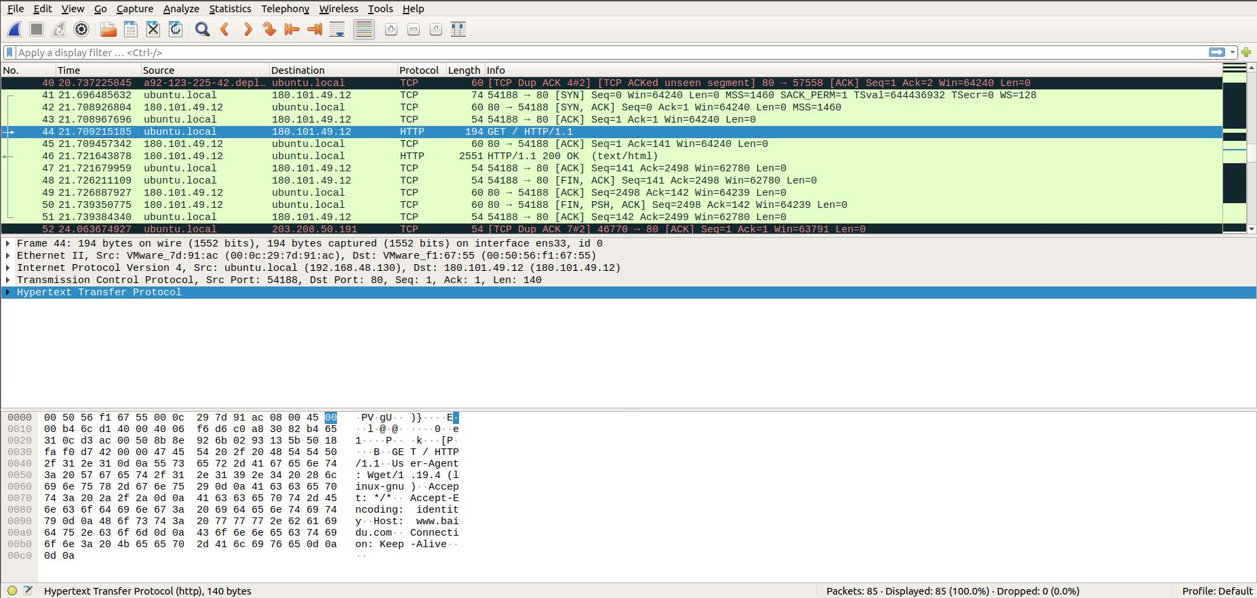

Figure 1: My screenshot of packet trace for wget traffic

Step 2: Inspect the Trace

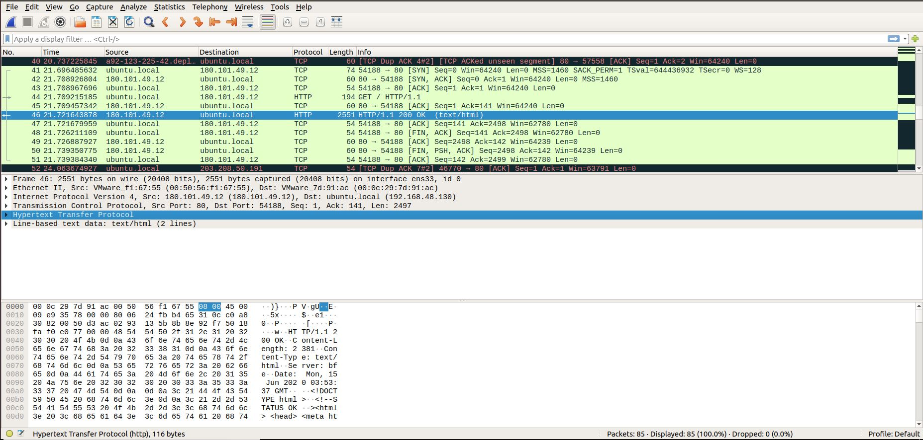

Figure 2: My screenshot of inspecting a HTTP “200 OK” response

Step 3: Packet Structure

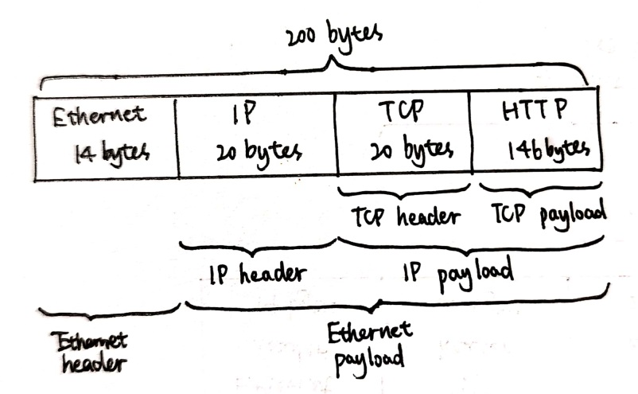

Step 4: Protocol Overhead

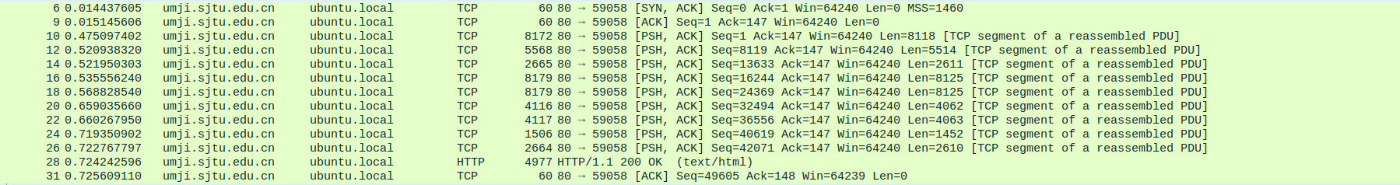

My estimate of download protocol overhead is 54×10=540 bytes.

Overhead rate

=(54+54+54+54+54+54+54+54+54+54)/(8172+5568+2665+8179+8179+4116+4117+1506+2664+4977)

=540/50143

=1.077%

Therefore, I find this overhead not very significant. It is quite acceptable.

Step 5: Demultiplexing Keys